Name :
Samarth Sanghi 63 Anuj Agrawal 46
Batch : B3

Practical 2:

Class diagram
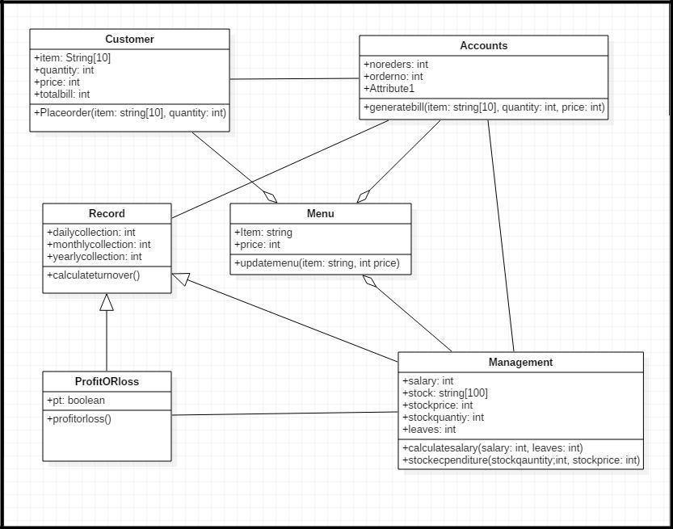

Practical3:

Sequence diagram
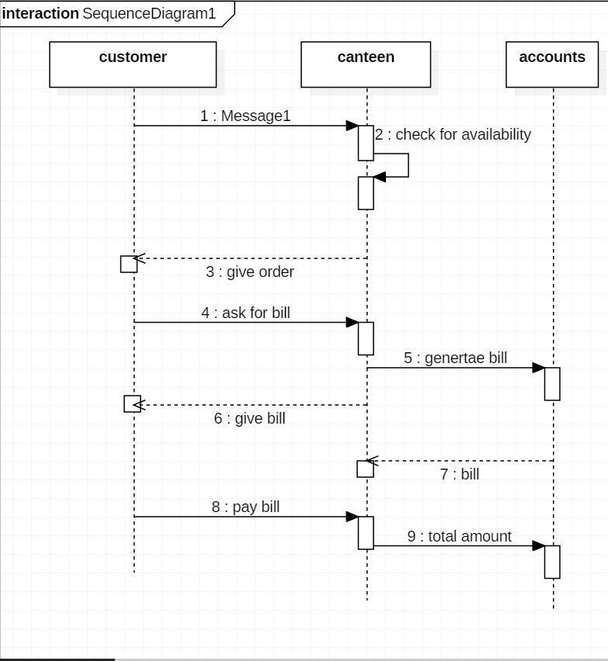

Practical 4-use case diagram
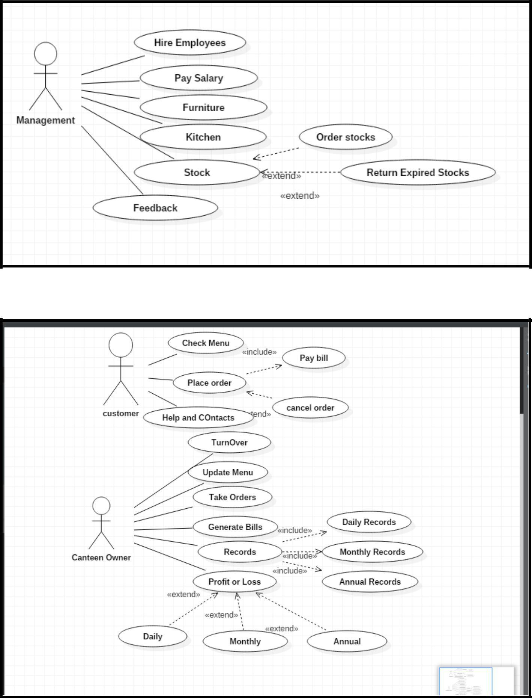

Practical 5:
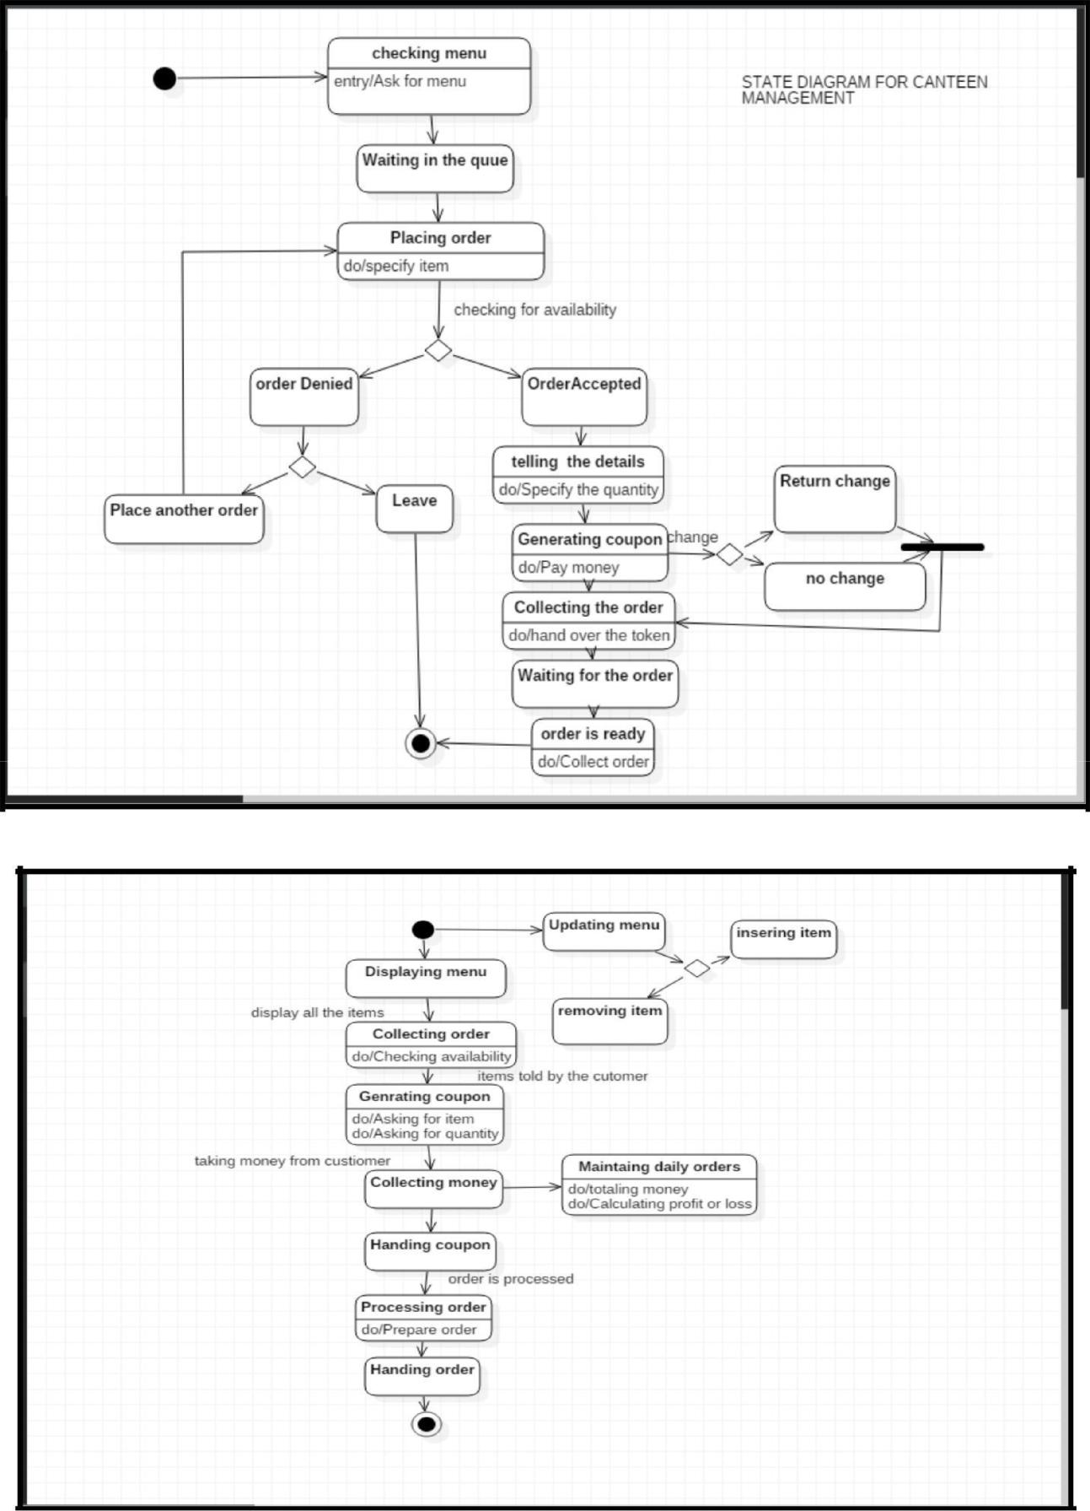

Practical 6:
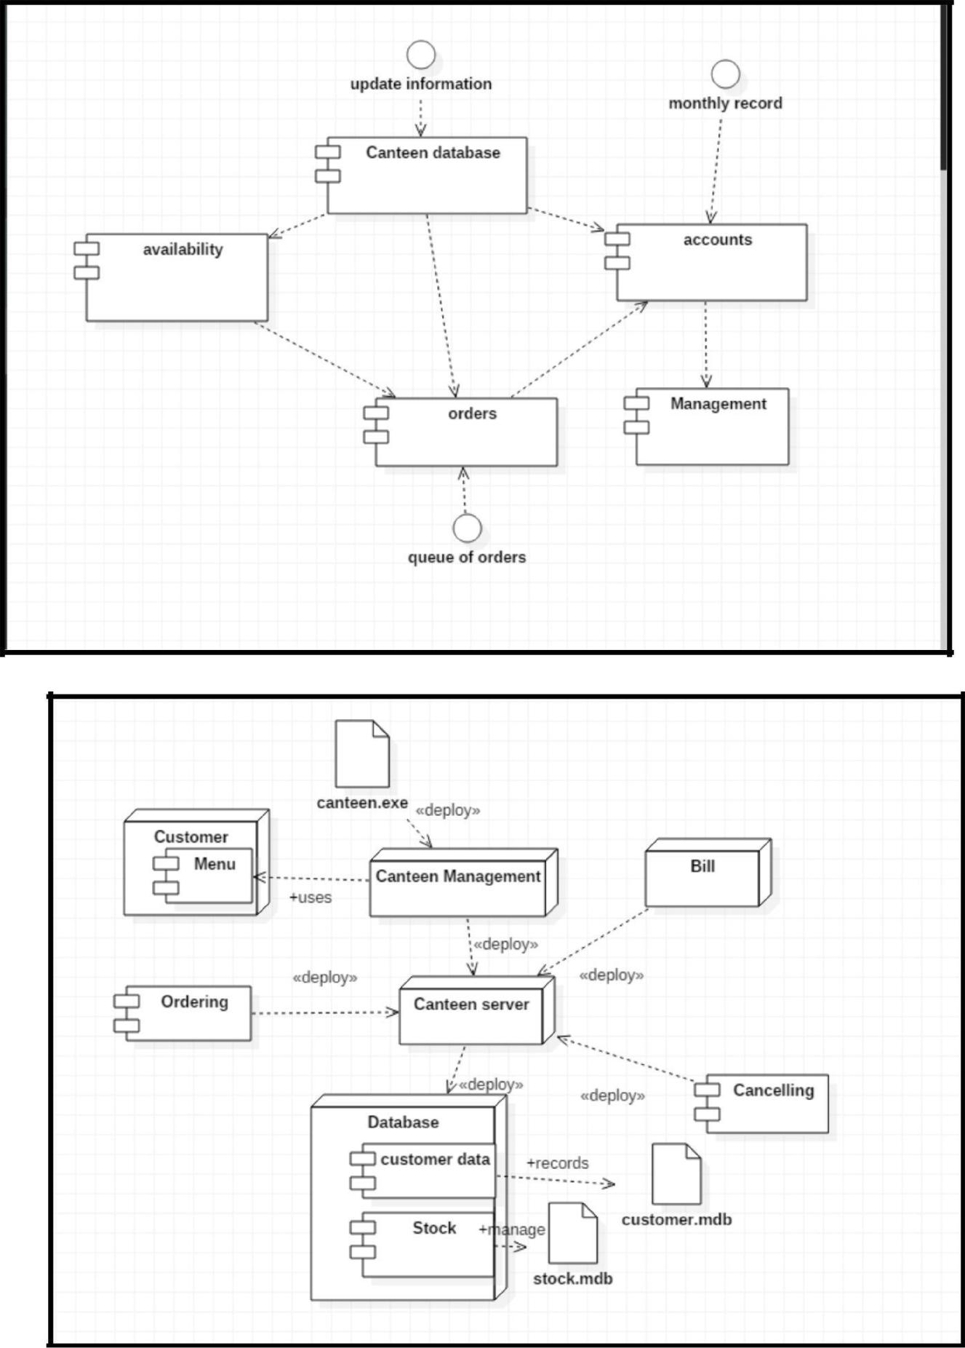
Practical 7:
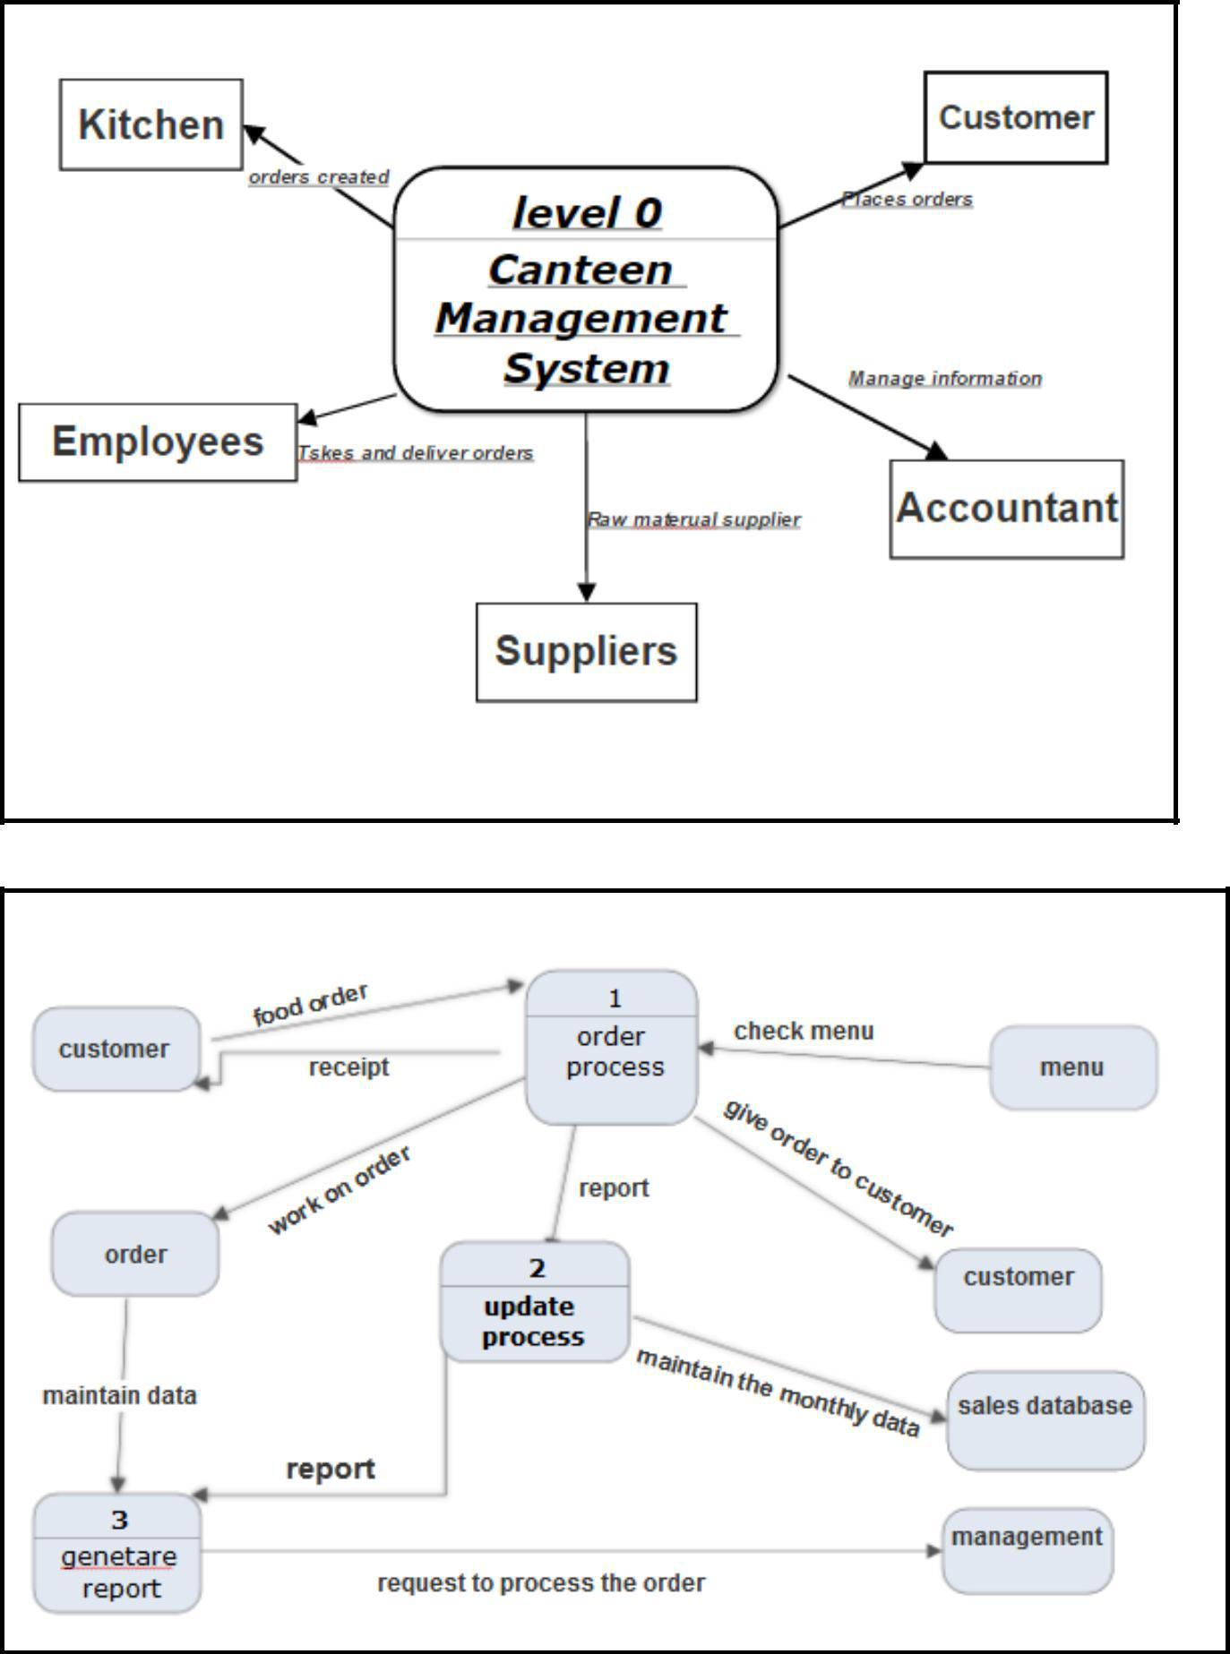
Practical 9:

Scenario | Case | Test case | Test step | Actual output | Expected
 | No. |  |  |  | output
Searching | 1 | Array contains 4 | 1-2-3-4-6 | Element not found | Element found
element |  | elements.1 2 3 4.And
 |  | element to be
 |  | searched is 1
Searching | 2 | Array contains 4 | 1-2-3-4-5 | Element found | Element not
element |  | elements.5 2 3 4.And |  |  | found
 |  | element to be
 |  | searched is 1
Accepting 4 | 3 | Elements entered are | 1-2 | Array index out of | 4 elements
array |  | 1 2 3 |  | bound | should be
elements |  |  |  |  | accepted
Search | 4 | Elements entered are | 1-2-3-4-5 | Element Found | Element Found
 |  | 1 2 3 4

Scenario | Case | Test case | Test step |  | Actual output |  | Expected
 | No. |  |  |  |  |  | output
Checking | 1 | Number Entered 4 | 1-2-4 |  | Prime No. |  | Not a prime no.
prime no.
Checking | 2 | Number Entered 0 | 1-2-3 |  |  |  | Not a prime
prime no.
prime no. |  |  |  |  | (Infinite loop)
Getting prime | 3 | Number Entered 5 | 1-2-3 |  | Prime no. |  | Prime no.
no.

Scenario | Case | Test case | Test step | Actual output | Expected
 | No. |  |  |  | output
Incomplete | 1 | Coordinates entered | 1-2-3-4-5 | Line from (100,100) to | Line from
line |  | (100,100) to |  | (175,100) | (100,100) to
 |  | (200,200) |  |  | (200,200)
No line | 2 | Coordinates entered | 1-2-3-4 | No line | Line from
 |  | (100,100) to |  |  | (100,100) to
 |  | (200,200) |  |  | (200,200)
Complete | 3 | Coordinates entered | 1-2-3-4-5-6 | Line from (100,100) to | Line from
line |  | (100,100) to |  | (200,200) | (100,100) to
 |  | (200,200) |  |  | (200,200)

Practical 10:

Creating Gmail Account

TestType of testScenarioExpected outcomeActual outcomeID1EasytoUser enters correctAccount created on gmailAccount created on gmailcompute datadata2BoundaryLength of passwordPassword strength :strongUse at least 8 characters.valueis exactly equal to 8Account createdDon’t use a passwordPassword:abcdf123from another site, orsomething too obviouslike your pet’s name3Typical casePassword containsAccount createdAccount createdalphabets as well assuccessfullysuccessfullynumbersPassword:abcd.1234Area of triangleTestType of testScenarioExpected outcomeActual outcomeID1EasytoUser enters simpleArea=0.5Area=0.5compute datavalueBase=1 height=12BoundaryBase=2 height=1Area=1Area=1value3Bogus dataBase= -2 height=33Base cannot be negativeSending Mail through Gmail AccountTestType of testScenarioExpected outcomeActual outcomeID1EasytoUser enters simpleEmail acceptedEmail acceptedcompute datavalueabc@gmail.com2BoundaryUser tries to sendMail sentFile size exceeding limitvaluemail of size morethan 25MB3Typical caseUser enters emailMail sentMail entabc@gmail.comand sends 10MBfile

